Assignment
Name:
Course Code/name:
Instructor:
Date: 18/07/2018

Abstract
Photovoltaic (PV) solar cells fitted on the roofs of many homes in the US play a key role in extracting solar energy. There are two main types of solar energy technology namely photovoltaics and the solar thermal. Solar phovoltaic, uses sunlight which detaches from the host silicon atoms. The tiny packets of the light energy is captured by the electrons and through the energy kick the electrons host the atom. Most of the circumstances, the photovoltaic modules are mounted on the roofs of the building and trap solar energy that is used in the homes.
Keywords: Solar energy, Photovoltaic (PV) solar cells, electricity

Introduction
Photovoltaic (PV) sun oriented cells fitted on the tops of numerous homes are great yet free assets that trap sunlight from the sun and change over the vitality into power. The Photovoltaic (PV) sunlight based cells/Solar cells are associated electronically and pressed together in a casing, regularly known as a sun oriented board. Solar-based cells are made of semiconductors, for example, silicon, which ingest the daylight and change over it into power. The electrical conduits are joined to positive and negative terminals, along these lines shaping an electrical circuit. From that point, the electrons can be caught as an electric current (power). This present, together with the cell's voltage (which is a consequence of its implicit electric field or fields), characterizes the power (or wattage) that the sun oriented cell can deliver. There are remain solitary PV frameworks and network associated PV frameworks. What makes them distinctive is that in the main case sun powered vitality is put away for individual utilize, while in a lattice associated close planetary system you can offer your excess of power back to the network (McEvoy, et. al., 2012). These Photovoltaic (PV) sunlight based cells/Solar cells are the way to fight greenhouse effects caused by pollution.
Description
The accompanying table demonstrates the shingle tallies and associated control, per rooftop surface. A sum of 586 shingles were utilized to furnish around 10 kW add up to limit with five inverters. The east rooftop surface was too substantial for one inverter, so two were used. The same SMA 2500U model was utilized for consistency and simplicity of support for every one of the four rooftop areas.
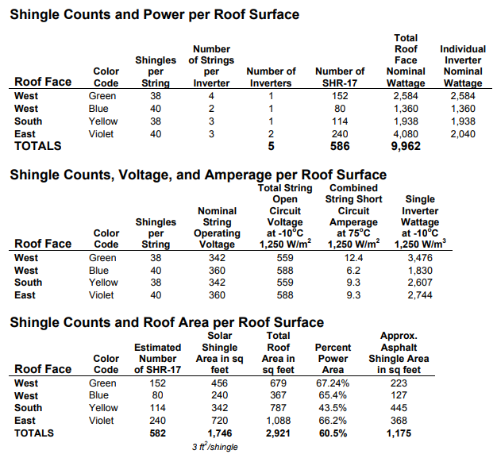
A photovoltaic framework is comprised of a few noteworthy parts including:
• Modules
• Mounting racks
• Inverter(s)
• Electric board
• Battery bank (discretionary).
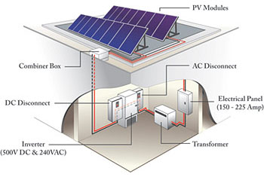
Typical grid-connected photovoltaic system
To begin with is the photovoltaic board or module. This is a board of photovoltaic cells made into an attentive framework with a power rating of some level, for example, 200 watts. Photovoltaic modules arrive in a wide assortment of sorts and sizes, so a photovoltaic framework can be intended to best match the space and heap of the undertaking. A photovoltaic module makes moderately low-voltage coordinate current (DC) power (Castañer, & Silvestre, 2012).
Conclusion
Solar panels costs have consistently diminished in the course of the most recent few years. Normal local sun oriented boards cost around £6,000. Sunlight based clusters in this value range can give you a framework yield of 4 kWh, delivering around 3,400 kWh every year, gave the sun based boards have a tendency of 30-50 degrees. The following, is an estimation of the amount you can hope to spend on sunlight based boards for home utilize.
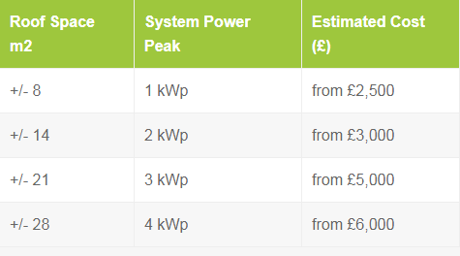

References
Castañer, L., & Silvestre, S. (2012). Modelling photovoltaic systems using PSpice. Chichester, England: J. Wiley.
McEvoy, A. J., Markvart, T., & Castañer, L. (2012). Practical handbook of photovoltaics: Fundamentals and applications. Waltham, MA: Academic Press.

